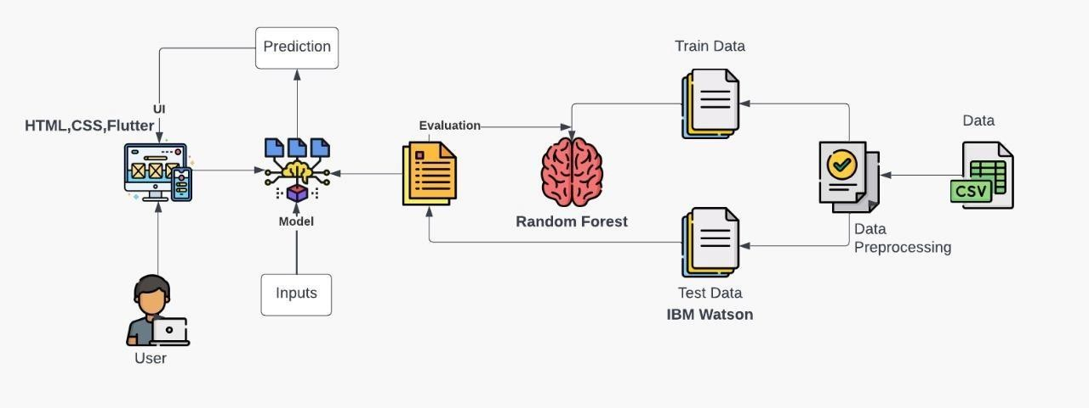

PROJECT DESIGN PHASE-II TECHNOLOGY ARCHITECTURE &

TECHNOLOGY STACK

|  |  |
| --- | --- |
| Date | 1 November 2022 |
| Team ID | PNT2022TMID54205 |
| Project Name | University Admit Eligibility Predictor |
| Maximum Marks | 4 Marks |

**TECHNICAL ARCHITECTURE:**

Table-1 : Components & Technologies:

|  |  |  |
| --- | --- | --- |
| **S.No** | **Component** | **Technology** |
| 1. | User Interface | Html, CSS, Flutter |
| 2. | Application Logic-1 | Python |
| 3. | Application Logic-2 | IBM Watson |
| 4. | Machine Learning Model | Random forest |

Table-2: Application Characteristics:

|  |  |  |
| --- | --- | --- |
| **S.No** | **Characteristics** | **Technology** |
| 1. | Open-Source Frameworks | Flask |
| 2. | Performance | It can handle about 100 requests per second |